# שאלה 1

נסמן ב- n את מספר האברים במחסנית, נסמן ב- m את מספר הספרות במספר

פתרון עם סיבוכיות O(n*m)

public static bool IsNumDigitInOrderInStack(int num, Stack<int> digits_stk)

{

Stack<int> clone = Clone(digits_stk);

Stack<int> helper_stk = new Stack<int>();

while (!clone.IsEmpty())

{

int num1_to_check = num;

bool found = true;

while (!clone.IsEmpty() && num1_to_check != 0)

{

int d1 = num1_to_check % 10;

int d2 = clone.Top();

if (num1_to_check % 10 != clone.Top())

found = false;

helper_stk.Push(clone.Pop());

num1_to_check /= 10;

}

if (found)

return true;

// not enough digits in stack

if (clone.IsEmpty() && num1_to_check != 0)

return false;

num1_to_check = num;

found = true;

while (!helper_stk.IsEmpty() && num1_to_check != 0)

{

if (num1_to_check % 10 != helper_stk.Top())

found = false;

clone.Push(helper_stk.Pop());

num1_to_check /= 10;

}

if (found)

return true;

clone.Pop();

}

return false;

}

נסמן ב- n את מספר האברים במחסנית,

סיבוכיות O(n)

public static int NumReverseDigits(int num)

{

int rev_num = 0;

while (num != 0)

{

rev_num *= 10;

rev_num += (num % 10);

num /= 10;

}

return rev_num;

}

public static int NumDigitsInNumber(int num)

{

int count = 0;

while (num != 0)

{

count++;

num /= 10;

}

return count;

}

public static bool IsNumDigitInOrderInStack2(int num, Stack<int> digits_stk)

{

int num_digs = NumDigitsInNumber(num);

int rev_num = NumReverseDigits(num);

Stack<int> clone = Clone(digits_stk);

int num_to_check = 0;

int i = 0; ;

while (i < num_digs && !clone.IsEmpty())

{

num_to_check *= 10;

num_to_check += clone.Pop();

i++;

}

if (i < num_digs)

return false;

if (num_to_check == num || num_to_check == rev_num)

return true;

while (!clone.IsEmpty())

{

num_to_check %= (int)Math.Pow(10, num_digs - 1);

num_to_check *= 10;

num_to_check += clone.Pop();

if (num_to_check == num || num_to_check == rev_num)

return true;

}

return false;

}

תוכנית בדיקה

public static void Test_IsNumDigitInOrderInStack()

{

int[] a = { 5, 8, 0, 2, 4, 7, 5, 9, 8, 3, 6, 5, 7, 3, 4, 7, 6, 8, 9, 2, 5, 4, 6, 7 };

Stack<int> s = StackUtils.CreateStackFromArray(a);

Console.WriteLine(s);

int num_to_check;

num_to_check = 76;

Console.WriteLine($"1. {num_to_check} in stack: {StackUtils.IsNumDigitInOrderInStack(num_to_check, s)}");

Console.WriteLine($"2. {num_to_check} in stack: {StackUtils.IsNumDigitInOrderInStack2(num_to_check, s)}");

num_to_check = 657347;

Console.WriteLine($"1. {num_to_check} in stack: {StackUtils.IsNumDigitInOrderInStack(num_to_check, s)}");

Console.WriteLine($"2. {num_to_check} in stack: {StackUtils.IsNumDigitInOrderInStack2(num_to_check, s)}");

num_to_check = 5298;

Console.WriteLine($"1. {num_to_check} in stack: {StackUtils.IsNumDigitInOrderInStack(num_to_check, s)}");

Console.WriteLine($"2. {num_to_check} in stack: {StackUtils.IsNumDigitInOrderInStack2(num_to_check, s)}");

num_to_check = 677;

Console.WriteLine($"1. {num_to_check} in stack: {StackUtils.IsNumDigitInOrderInStack(num_to_check, s)}");

Console.WriteLine($"2. {num_to_check} in stack: {StackUtils.IsNumDigitInOrderInStack2(num_to_check, s)}");

num_to_check = 776;

Console.WriteLine($"1. {num_to_check} in stack: {StackUtils.IsNumDigitInOrderInStack(num_to_check, s)}");

Console.WriteLine($"2. {num_to_check} in stack: {StackUtils.IsNumDigitInOrderInStack2(num_to_check, s)}");

num_to_check = 8024;

Console.WriteLine($"1. {num_to_check} in stack: {StackUtils.IsNumDigitInOrderInStack(num_to_check, s)}");

Console.WriteLine($"2. {num_to_check} in stack: {StackUtils.IsNumDigitInOrderInStack2(num_to_check, s)}");

num_to_check = 4208;

Console.WriteLine($"1. {num_to_check} in stack: {StackUtils.IsNumDigitInOrderInStack(num_to_check, s)}");

Console.WriteLine($"2. {num_to_check} in stack: {StackUtils.IsNumDigitInOrderInStack2(num_to_check, s)}");

}

# שאלה 2

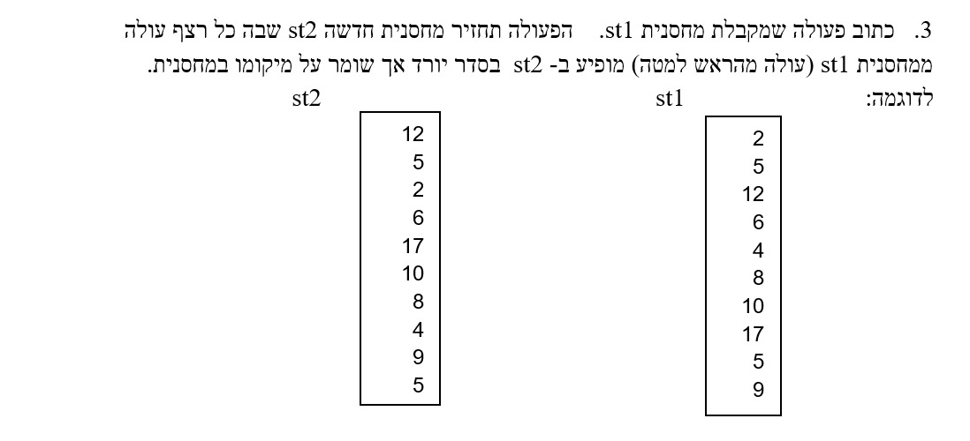

# שאלה 3

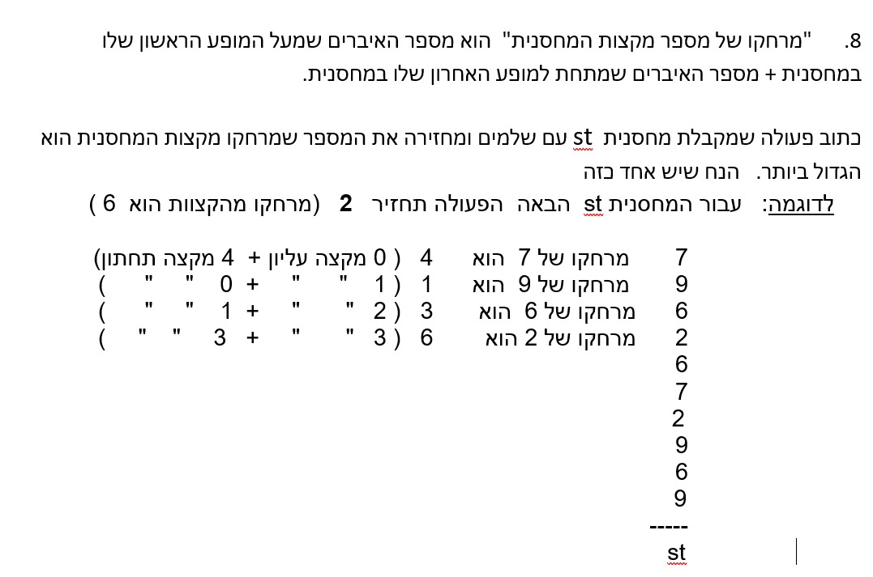

# שאלה 4

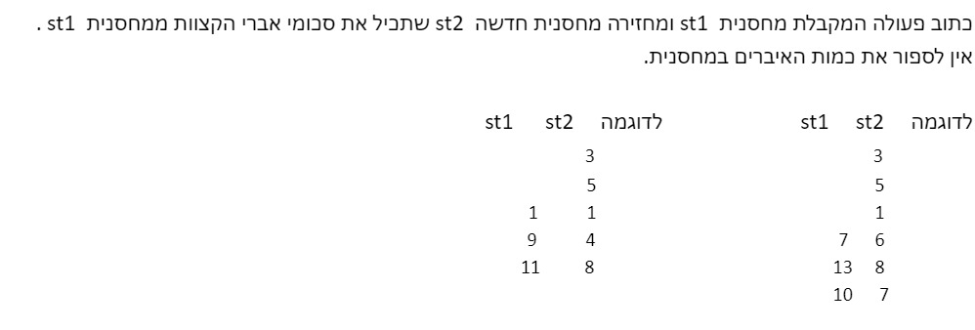

# שאלה 5

נתונה הפעולה DoIt



